|  |  |
| --- | --- |
| **Name:** | Vinith Shetty |
| **Roll No:** | 55 |
| **Class/Sem:** | SE/IV |
| **Experiment No.:** | 2A |
| **Title:** | Program to perform multiplication without using MUL instruction |
| **Date of Performance:** | 30/01/2024 |
| **Date of Submission:** | 6/02/2024 |
| **Marks:** |  |
| **Sign of Faculty:** |  |

**Aim:** Program for multiplication without using the multiplication instruction.

**Theory:**

In the multiplication program, we multiply the two numbers without using the direct instructions MUL. Here we can successive addition methods to get the product of two numbers. For that, in one register we will take multiplicand so that we can add multiplicand itself till the multiplier stored in another register becomes zero.

**ORG 100H:**

It is a compiler directive. It tells the compiler how to handle source code. It tells the compiler that the executable file will be loaded at the offset of 100H (256 bytes.) **INT 21H:**

The instruction INT 21H transfers control to the operating system, to a subprogram that handles I/O operations.

**MUL:** MUL Source.

This instruction multiplies an unsigned byte from some source times an unsigned byte in the AL register or an unsigned word from some source times an unsigned word in the AX register.

Source: Register, Memory Location.

When a byte is multiplied by the content of AL, the result (product) is put in AX. A 16-bit destination is required because the result of multiplying an 8-bit number by an 8-bit number can be as large as 16-bits. The MSB of the result is put in AH and the LSB of the result is put in AL.

When a word is multiplied by the contents of AX, the product can be as large as 32 bits. The MSB of the result is put in the DX register and the LSB of the result is put in the AX register.

MUL BH; multiply AL with BH; result in AX.

Algorithm:

1. Start.
2. Set AX=00H, BX= Multiplicand, CX=Multiplier 3 Add the content of AX and BX.
3. Decrement content of CX.
4. Repeat steps 3 and 4 till CX=0.
5. Stop.

Code:

ORG 100H

MOV AX, 00H

MOV BX, 04H

MOV CX, 02H

L1: ADD AX, BX

DEC CX

JNZ L1

RET

Output:

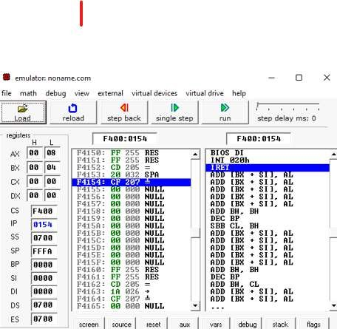

Flowchart:

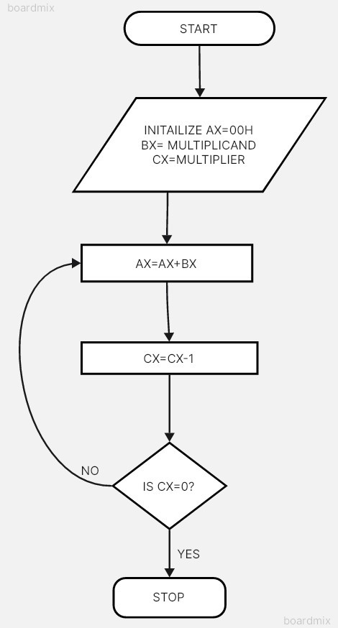

Conclusion:

1. Explain data transfer instructions.
2. Explain Arithmetic instructions.

Answer:-

1) Data transfer instructions in the 8086 microprocessor are used to move data between memory locations, registers, and input/output (I/O) devices. These instructions are essential for manipulating data within a program, as well as for communicating with external devices.

2)Arithmetic Instructions are the instructions which perform basic arithmetic operations such as addition, subtraction and a few more. Unlike in 8085 microprocessor, in 8086 microprocessor the destination operand need not be the accumulator.